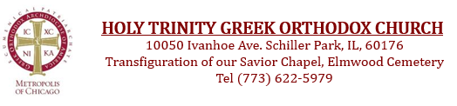

Schiller Park Greek Festival 2026 (JUNE 5-7, 2026)

We are thrilled to announce the grand revival of Holy Trinity's esteemed annual Greek Festival, now to be held at our new, magnificent location in Schiller Park. Your presence at this momentous occasion would be an honor. We kindly invite you to explore the many avenues through which you can contribute to the success of the Schiller Park Greek Festival. Your invaluable support will undoubtedly elevate this event to unparalleled heights of jubilation and cultural celebration.

Name: |  | Business Name:

Mailing Address: |  | City: |  | State: |  | Zip:

Phone: |  | Email Address:

Sold By:

Please email this completed Sponsorship Form to dhaleas@yahoo.com or mail to Holy Trinity 10050
Ivanhoe Ave, Schiller Park, along with payment, by the Sponsorship deadline date May 20

Check

Make checks payable to Holy Trinity Greek Orthodox Church with 2026 Festival in the memo.

Credit Card

Name as it appears on the credit card:

Card Type: |  | Card Number:

Expiration Date: |  | CSV: |  | Amount: $

Signature:

ARTWORK / LOGO SUBMISSIONS INSTRUCTIONS
All artwork is due no later than May 20 (anything received after deadline date will not be included)
Email to dhaleas@yahoo.com

